**Periodická tabuľka prvkov – Názvy skupín**

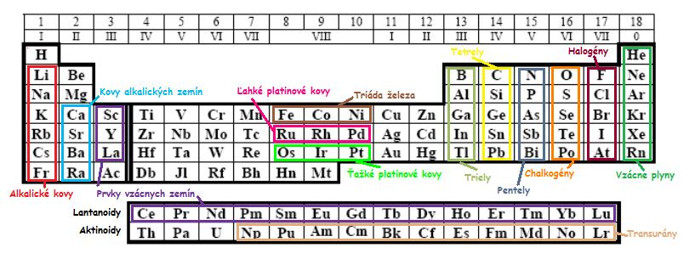

**Periodický tabuľka prvkov**

|  |  |  |  |  |  |  |  |  |  |  |  |  |  |  |  |  |  |  |  |  |  |  |  |  |  |  |  |  |  |  |  |  |  |  |  |  |  |  |  |  |  |  |  |  |  |  |  |  |  |  |  |  |  |  |  |  |  |  |  |  |  |  |  |  |  |  |  |  |  |  |  |  |  |  |  |  |  |  |  |  |  |  |  |  |  |  |  |  |  |  |  |  |  |  |  |  |  |  |  |  |  |  |  |  |
| --- | --- | --- | --- | --- | --- | --- | --- | --- | --- | --- | --- | --- | --- | --- | --- | --- | --- | --- | --- | --- | --- | --- | --- | --- | --- | --- | --- | --- | --- | --- | --- | --- | --- | --- | --- | --- | --- | --- | --- | --- | --- | --- | --- | --- | --- | --- | --- | --- | --- | --- | --- | --- | --- | --- | --- | --- | --- | --- | --- | --- | --- | --- | --- | --- | --- | --- | --- | --- | --- | --- | --- | --- | --- | --- | --- | --- | --- | --- | --- | --- | --- | --- | --- | --- | --- | --- | --- | --- | --- | --- | --- | --- | --- | --- | --- | --- | --- | --- | --- | --- | --- | --- | --- | --- |
| |  |  |  |  |  |  |  |  |  |  |  |  |  |  |  |  |  |  |  |  |  |  |  |  |  |  |  |  |  |  |  |  |  |  |  |  |  |  |  |  |  |  |  |  |  |  |  |  |  |  |  |  |  |  |  |  |  |  |  |  |  |  |  |  |  |  |  |  |  |  |  |  |  |  |  |  |  |  |  |  |  |  |  |  |  |  |  |  |  |  |  |  |  |  |  |  |  |  |  |  |  |  |  |  | | --- | --- | --- | --- | --- | --- | --- | --- | --- | --- | --- | --- | --- | --- | --- | --- | --- | --- | --- | --- | --- | --- | --- | --- | --- | --- | --- | --- | --- | --- | --- | --- | --- | --- | --- | --- | --- | --- | --- | --- | --- | --- | --- | --- | --- | --- | --- | --- | --- | --- | --- | --- | --- | --- | --- | --- | --- | --- | --- | --- | --- | --- | --- | --- | --- | --- | --- | --- | --- | --- | --- | --- | --- | --- | --- | --- | --- | --- | --- | --- | --- | --- | --- | --- | --- | --- | --- | --- | --- | --- | --- | --- | --- | --- | --- | --- | --- | --- | --- | --- | --- | --- | --- | --- | | |  |  |  |  |  |  |  |  |  |  |  |  |  |  |  |  |  |  |  |  |  |  |  |  |  |  |  |  |  |  |  |  |  |  |  |  |  |  |  |  |  |  |  |  |  |  |  |  |  |  |  |  |  |  |  |  |  |  |  |  |  |  |  |  |  |  |  |  |  |  |  |  |  |  |  |  |  |  |  |  |  |  |  |  |  |  |  |  |  |  |  |  |  |  |  |  |  |  |  |  |  | | --- | --- | --- | --- | --- | --- | --- | --- | --- | --- | --- | --- | --- | --- | --- | --- | --- | --- | --- | --- | --- | --- | --- | --- | --- | --- | --- | --- | --- | --- | --- | --- | --- | --- | --- | --- | --- | --- | --- | --- | --- | --- | --- | --- | --- | --- | --- | --- | --- | --- | --- | --- | --- | --- | --- | --- | --- | --- | --- | --- | --- | --- | --- | --- | --- | --- | --- | --- | --- | --- | --- | --- | --- | --- | --- | --- | --- | --- | --- | --- | --- | --- | --- | --- | --- | --- | --- | --- | --- | --- | --- | --- | --- | --- | --- | --- | --- | --- | --- | --- | --- | | |  |  |  |  |  |  |  |  |  | | --- | --- | --- | --- | --- | --- | --- | --- | --- | | **Značka prvku** | **Názov prvku** | **Protónové číslo** | **Celkový počet elektrónov** | **perióda** | **skupina** | **Počet elektrónov vo /valenčnej/ vrstve** | **Kov, nekov, polokov** | **Podľa názvu skupiny** | | Si | kremík | 14 | 14 | 3. | IV. A | 4 | polokov | tetrely | |  |  |  |  | 4. |  |  |  | vzácne plyny | |  |  | 78 |  |  |  | ––– |  |  | |  | vápnik |  |  |  |  |  |  |  | |  |  |  |  | 4. |  | 7 |  |  | |  |  |  | 12 |  |  |  |  |  | |  |  |  |  | 3. | I. A |  |  |  | |  |  |  |  |  | IV. A |  | nekov |  | | Cu |  |  |  |  |  | –––– |  |  | |  |  |  |  | 2. |  |  | polokov |  | |  | |  | | | |

**Periodická tabuľka prvkov**

